# DB1tools running on a Windows PC

## Introduction

The DB1 Tools are the tools we are going to use for programming the [Huzzah32 board](https://www.adafruit.com/product/3591) used in this course. They are based on Visual Studio Code (VSC) and some plugins that make it easy to communicate with the board and provide autocompletion, syntax highlighting and help when writing you code for the board. The programing language used to write code for the Huzzah32 in this course is called MicroPython.

The tools are installed in a Docker container, which you can think of as a virtual computer running on top of Ubuntu (a distribution of the Linux operating system). To make them work on your Windows PC we need to install Ubuntu on your computer with the help of Windows Subsystem for Linux (WSL). The installation script will try to install Ubuntu (and eventually WSL) automatically but in case that fails you might need to install them separately.

## Installation troubleshooting

If you are having trouble installing the tools, try these troubleshooting steps:

* Update the operating system.
* Disable your antivirus software while installing the DB1 tools and reenable it right after that.
* Disable you firewall or set it up in an interactive mode so that you can see when the tools are trying to establish new connections. Reenable the firewall after the DB1 tools are installed.

## Prerequisites

You need to have an up-to-date version of windows 10 or windows 11.

## Installation instructions:

1. **Download the DB1 tools from GitHub**. Open the following address in your web browser:

<https://github.com/edwarddtu/db1>

From there download the code as a zip file (you can also close the repository if you are familiar with GitHub). To download the code as a zip file you need to click on the green “Code” button and then on Download Zip as shown in Figure 1.

Figure 1 How to download the DB1Tools from GitHub

1. **Unzip the downloaded file** in a directory of your choosing. It should be a directory that you can find easily. A recommended directory to use is the Desktop directory. After you unzip the tools, you will get a subdirectory containing the following directories:
   1. Win (directory containing the installation files for a Windows computer)
   2. Mac (directory containing the installation files for a Mac computer)
   3. Lin (directory containing the installation files for a Linux computer)
   4. Common (Files that are common to installation for all 3 operating systems)
   5. DefaultProj (files used inside the container for the default project for the db1tools)
2. **Make sure that Ubuntu and WSL are installed correctly.** We fist go to the Win directory where the necessary scripts to install the DB1 tools are located. Then right click on the windows_installation_step1.bat file and select “Run as Administrator” as shown in Figure 2

Figure 2 Running scripts as administrator.

The reason we need to run the scripts as administrator is because the installation script requires elevated rights to install programs. In case you get a security warning when trying to run the scripts like the ones in Figure 3 then you should click on Run or OK so that the script can be executed. To avoid being asked every single time you run a batch file you can uncheck “Always ask before opening this file”.

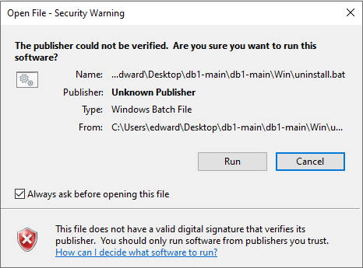

Figure 3 Security warnings

Depending on whether the Ubuntu and WSL were already installed or are installed by the script you will get different messages on the screen. For example, if Ubuntu is installed by the script, then you will be asked to input a username and password as shown in Figure 4 . The username can be different from the one you use for windows but if should be different from “root”.

Figure 4 Creating a username and password for Ubuntu

You know that Ubuntu was installed correctly when you get a message like “Welcome to Ubuntu” at the end of the script execution and when the last line in the terminal window is like the one shown in Figure 3.

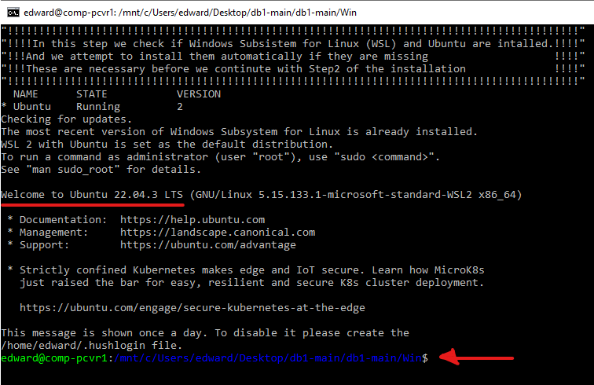

Figure 5 Ubuntu is installed OK

The first word shown with green is the default username for the Ubuntu operating system. In this case the username is edward. It’s highly recommended that the default username is NOT root. It should be the one used when you’ve installed Ubuntu.

In case Ubuntu and WSL cannot be installed automatically with the help of the install script then you’ll need to install it by hand. You can do this by following the instructions in this web site (up to step 4):

<https://ubuntu.com/tutorials/install-ubuntu-on-wsl2-on-windows-11-with-gui-support>

1. **Install the db1tools.** Now that Ubuntu is installed and running on the computer, we can install the tools using the script windows_installation_step2.bat. You’ll have to run this script also as administrator by right-clicking on it and then selecting “Run as Administrator”. When the installation is completed, you should get a message like the one in Figure 6. You can close this window now.

Figure 6 Installation is finished

NOTE: Make sure you don’t erase the folder that you’ve used to install the DB1 tools from. The scripts that are used to start the tools and connect and disconnect the serial port to WSL are also there.

1. Start the DB1Tools. You can do that by double clicking on the desktop icon A black and white logo

   Description automatically generated. This should start the docker container where the tools are installed and open the user interface for the tools in the web browser at the address <http://localhost:8080> . The first time you start the tools you will be asked if you trust the author of the default project. You should say yes and select the checkbox so that you don’t have to answer this question in the future as shown in Figure 7.

Figure 7 Trusting the default project files

## Icons on Desktop

After you have finalized the installation of the DB1tools you will see some new icons on the desktop:

If you doble-click on this link, you’ll see in windows explorer the files the docker is using in Ubuntu. The user directory is directory where the user files are saved. One of the important subdirectories is DB1 contains the files for the DB1 project we use in this course.

By double-clicking on this link, you can connect the serial port of the Huzzah32 board with WSL. When connected to WSL the serial port is removed from the list of serial ports available to Windows.

By double-clicking on this link, you can disconnect the serial port of the Huzzah32 board with WSL. As soon as it gets disconnected from WSL it’s going to reconnect back to Windows.

By double-clicking on this link, you can start the DB1tools. If the huzzah board is already connected to WSL, then it’s going to be available for the tools. You can still use the tools if the board is not connected but only for editing (not for communicating with the board.

## Connecting the huzzah board with the container where the DB1 tools are running

**Step 1 - We need to make sure that the Huzzah32 board can properly connect to Windows.**

First connect your Huzzah32 board with a USB cable to your PC. Then open the Device Manager (press on the keyboard on windows key + X, and then select “Device Manager”). In the Device Manager select Ports (COM and LPT). There you can see if the Huzzah board is recognized as a COM port. If it’s correctly recognized by windows, then you should see something like in Figure 8. You should see a serial port with a description like this: Silicon Labs CP2010x USB to UART Bridge (COMxx) – where the xx stands for the number of the COM port used by the board. This can be different from case to case.

Figure 8 Huzzah32 board connected as a Silicon Labs CP210x USB to UART Bridge

In case the board is not shown as a Silicon Labs CP210x COM port then it’s most likely that the device is not installed. You can download the driver from this link: <https://www.silabs.com/documents/public/software/CP210x_Universal_Windows_Driver.zip>

In case the link does not work you can go to web page with the download links:

<https://www.silabs.com/developers/usb-to-uart-bridge-vcp-drivers?tab=downloads>

You can watch [this video](https://youtu.be/r_eMEXvt0v0) for information about how the driver is installed.

**Step2 – Connect the Huzzah board to WSL**

First make sure that WSL is running.

*Hint: It’s a good idea to keep the Device manager window open where you expand the Ports (COM & LPT section) in the background so that you can easily see if the Huzzah board is connected to Windows or not. When it gets connected to WSL is removed from the list of devices that are connected to Windows.*

**Step3 – Start the DB1 Tools**

At step 2 they were running without the serial port that allows communication to the Huzzah32 board. This time around because the board is connected, we can also use the tools to communicate with the board.